**Site Plan Document**

**Site Name:** The name for this site is Plant Care Green Leaf. The name will be in the <title> in the html structure, it also will appear in the header with an <h1> tag and next to the name will be a logo of a green leaf. The name was chosen because a green leaf represents the color of life and well care in plants.

**Site Purpose:** This site will allow the user to understand better the care of plants. In this site the user will find photos of a variety of plants and information for their well care. The purpose of the site will appear with a short paragraph <p> in the header of the site.

**Scenarios:** Two scenarios are provided for this web site in the home page. The first one answer the question that maybe could ask the user, and it is: Why my plant leaves are turning yellow? To answer that question, I will create a <section> in the home page that will show the topic in an <h2> that will say “Plant Issues and How to Solve Them”. This will have a sub-topic in a <div> with a <h3> tag that will say “Yellow Leaves” and will explain how to solve the problem in a <p>. Fort the second question that maybe could ask the user could be “How could I supports the healthy development in my plant?”. The answer for this question could be “Compost as a Natural Fertilizer”. This topic will be in a <h3> tag in a <section> and inside the section will be a <div> with the sub-topic in a <h2> that will say “The Power of The Compost to Your Plants” and then will be a paragraph with a <p> showing information regards this sub-topic.

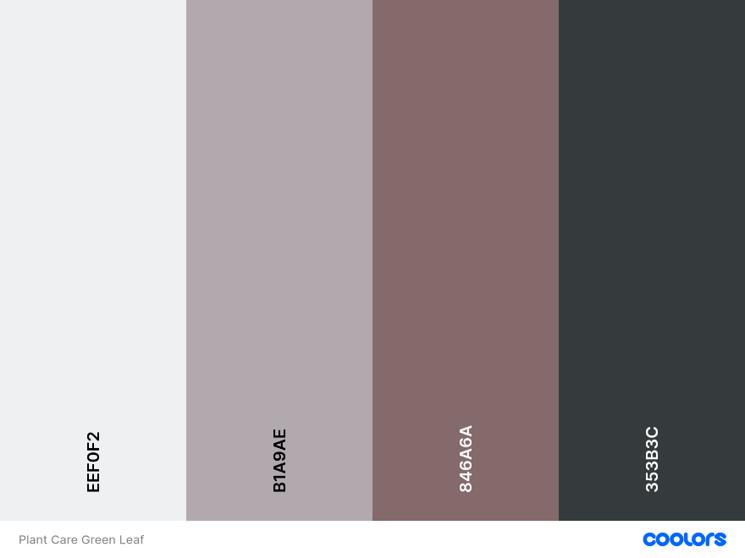**Color Schema:** For this web page the color schema would be apply with some variables through CSS. For the background-color would be #EEF0F2, for text-color would be #353B3C, for the header and footer the color would be #B1A9AE, and for the menu #846A6A.

**Typography:**  The typography for this project will be “Roboto” and “Sans Serif”. Those would be applied in the body of the web page with a font-weight of 400.Also these would be applied in the <h1> tag with a font-weight of 300 and to the <h2> with a font weight of 400.

**Wireframe:**

**Desktop View**

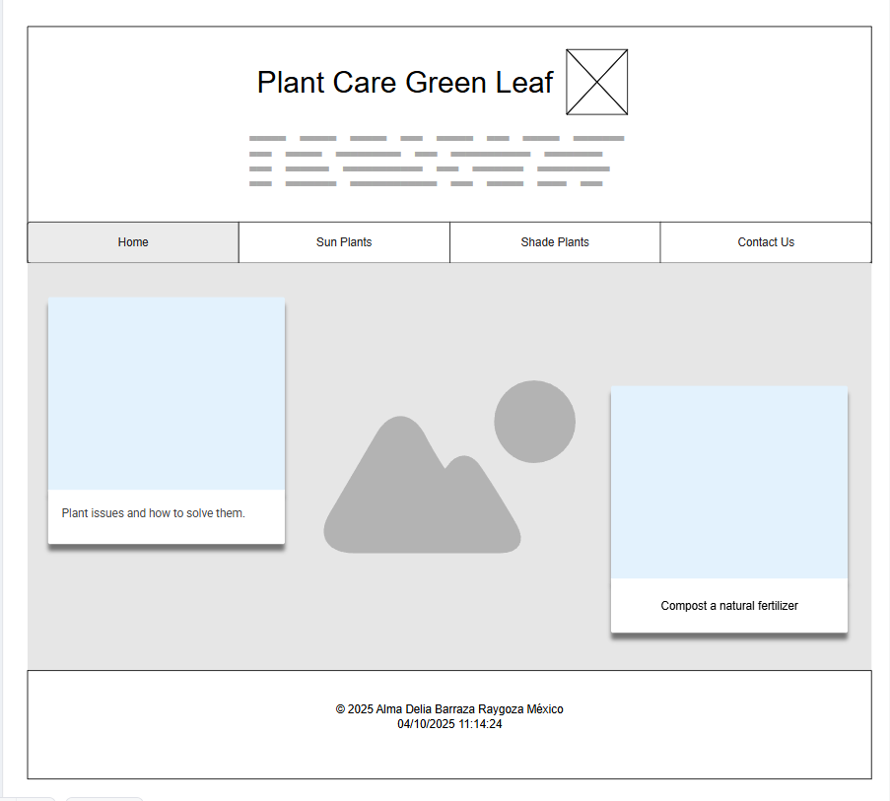

**Mobile View**

